**Instagram**



**Business Requirements Documents**

**For**

Implementation Of

“Voice Captions On The Instagram Application”

25/01/2025

**Revision History**

|  |  |  |  |
| --- | --- | --- | --- |
| **Date Version Author Change** | | | |
| 25/01/2025 | 1 | Apaar Jain | 1st Draft |
|  |  |  |  |
|  |  |  |  |
|  |  |  |  |

**Contributors To The Document**

| **Name** | **Department** | **Role** | **Contribution** |
| --- | --- | --- | --- |
| **Jane Doe** | **Product Management** | **Product Manager** | Defined the overall vision and objectives of the audio captions feature, ensuring alignment with Instagram’s product strategy. |
| **John Smith** | **Engineering** | **Lead Software Engineer** | Provided technical feasibility input and ensured that the feature’s development aligns with Instagram’s existing infrastructure and capabilities. |
| **Sarah Johnson** | **Design** | **UX/UI Designer** | Designed user-friendly interfaces for recording and playing audio captions within the Instagram app, focusing on enhancing the user experience. |
| **David Lee** | **Marketing** | **Marketing Specialist** | Defined the target audience for the new feature, ensuring that it meets user needs and is aligned with marketing goals. |
| **Lisa Turner** | **Data Analytics** | **Data Analyst** | Provided insights on user engagement and behavior analysis to ensure that the feature would be effective in increasing engagement and retention. |
| **Michael Brown** | **Legal & Compliance** | **Legal Advisor** | Ensured that the new feature complies with data privacy laws, including GDPR, and other regulatory requirements related to user-generated content. |
| **Emma Williams** | **Operations** | **Operations Manager** | Provided input on operational processes for handling increased audio data storage, ensuring that the infrastructure can scale as required. |
| **James White** | **Customer Support** | **Customer Support Manager** | Offered feedback on common user concerns and provided insights into how customer support could assist with any issues users may encounter when using audio captions. |
| **Apaar Jain** | **Project Management** | **Business Analyst** | Led the overall project, ensuring that both the technical and business aspects of the feature were properly aligned, and guided the development of the FRD and BRD. |

**Table Of Contents**

**Introduction** 5

Purpose 5

Document Management 6

Document Storage 6

Document Distribution 6

Revision Control 7

Organizational Areas Affected 7

Reason For Project and Project Methodology 9

**Overview** 10

Business Purpose 10

Measures Of Success 11

Project Priorities 13

**Project Diagrams** 15

System Architecture 15

Entity Relationship Diagram 17

Process Flow Diagram 18

**Assumptions/Constraints/Risks/Dependencies** 19

Assumptions 19

Risks 19

Constraints 20

Dependencies 21

**Statement Of Business Requirements** 22

Background 22

Current Environment 23

Challenges in the Current Environment 23

Opportunities for Improvement 24

Impact On System’s And Processes 24

**Business Process** 26

Current 26

New Process 29

**Systems Requirements** 31

Functional Requirements 31

Non-Functional Requirements 31

Definition Of Completion 32

User Stories Summary 33

**Impact Urgency** 34

**Approvals** 37

# **Introduction**

The **Audio Captions Feature** for Instagram is a new enhancement aimed at transforming how users engage with content on the platform. The feature allows users to add audio captions to their posts, enabling a more inclusive and accessible experience, while also offering a creative way to communicate through voice rather than text. This feature aligns with Instagram’s commitment to continuously improve user experience and expand the ways users can interact with content.

With the increasing demand for multimedia communication, adding audio as a form of caption not only supports accessibility for users with visual impairments but also enhances user engagement by providing an additional, personalized layer to their posts. The project will empower users to record, edit, and post audio alongside their images or videos, allowing for more versatile and dynamic content creation.

This document outlines the **business requirements** for the development and implementation of the **Audio Captions Feature** on Instagram. The focus is on defining the business goals, objectives, and the scope of the project. It also highlights key deliverables, stakeholders, and success criteria, ensuring alignment between business and technical teams for successful project execution

## Purpose

The purpose of this **Business Requirements Document (BRD)** is to define and document the business requirements for the implementation of the **Audio Captions Feature** on Instagram. This document serves as the primary point of reference for all stakeholders, ensuring a shared understanding of the project’s scope, objectives, and expected outcomes.

The BRD outlines the business goals and objectives that this feature will address, including enhancing user engagement, improving accessibility, and offering a more dynamic user experience. It also defines the key deliverables, success criteria, and high-level milestones necessary for the project’s success.

By clearly establishing the business requirements, the BRD ensures that both business and technical teams are aligned and that the project meets the needs of Instagram’s diverse user base. This document will also guide the decision-making process, helping to manage resources, set priorities, and mitigate risks throughout the project lifecycle.

## Document Management

The Document Management section defines how the Business Requirements Document (BRD) will be maintained, updated, and tracked throughout the project lifecycle. It ensures that the document remains accurate, accessible, and relevant to all stakeholders.

## Document Storage

The BRD and related documents will be stored in a centralized project repository accessible to all authorized stakeholders. The repository will be organized in folders by version, with clear version control to ensure the latest version is always in use.

## Document Distribution

| **Recipient** | **Role** | **Format** | **Frequency** |
| --- | --- | --- | --- |
| **Project Manager** | Oversees overall project execution | Digital (PDF/Word) | Once, with updates as needed |
| **Product Manager** | Defines product vision and strategy | Digital (PDF/Word) | Once, with updates as needed |
| **Engineering Team** | Responsible for technical execution | Digital (PDF/Word) | Once, with updates as needed |
| **UX/UI Designer** | Designs user interfaces and experiences | Digital (PDF/Word) | Once, with updates as needed |
| **Marketing Team** | Defines target audience and messaging | Digital (PDF/Word) | Once, with updates as needed |
| **Data Analyst** | Analyzes user data and engagement | Digital (PDF/Word) | Once, with updates as needed |
| **Legal and Compliance Team** | Ensures compliance with laws and regulations | Digital (PDF/Word) | Once, with updates as needed |
| **Operations Team** | Manages operational implementation | Digital (PDF/Word) | Once, with updates as needed |
| **Customer Support Team** | Handles customer inquiries and issues | Digital (PDF/Word) | Once, with updates as needed |
| **Business Analysts** | Drafts and refines business requirements | Digital (PDF/Word) | Once, with updates as needed |
| **Executive Team** | Provides oversight and final approvals | Digital (PDF/Word) | Once, with updates as needed |

## Revision Control

Any revisions to the BRD must be clearly documented, including the version number, date of the revision, a description of the changes, and the names of the individuals responsible for the changes. Each version of the BRD will be subject to review and approval by PMC's project sponsor before being finalized.

## Organizational Areas Affected

1. **Product Management**

* **Impact**: Product managers will need to integrate this new feature into Instagram's overall product roadmap and ensure it aligns with user needs and market trends.
* **Key Considerations**: Defining user stories, understanding feature requirements, prioritizing the feature, and ensuring alignment with Instagram's broader strategy.

1. **Engineering and Development**

* **Impact**: The engineering team will be responsible for the technical implementation of the audio captions feature, which involves backend development, API integrations, storage, and ensuring performance scalability.
* **Key Considerations**: Software architecture changes, data storage, cloud infrastructure, security, and testing for robustness.

1. **Design (UX/UI)**

* **Impact**: The design team will create the user interface for recording, editing, and playing audio captions within Instagram’s app and web platforms.
* **Key Considerations**: User experience, interface design, accessibility features (e.g., for visually impaired users), and ensuring seamless integration with existing post features.

1. **Marketing**

* **Impact**: Marketing will promote the new feature, targeting relevant user segments and generating awareness about the functionality. The feature can also provide a unique selling point for attracting new users.
* **Key Considerations**: Identifying target audiences, creating marketing campaigns, tracking engagement metrics, and positioning the feature to drive user retention.

1. **Data Analytics**

* **Impact**: Data analysts will track and analyze user engagement with the audio captions feature, collecting feedback on usage patterns, user behavior, and identifying trends.
* **Key Considerations**: Setting up analytics dashboards, monitoring KPIs (e.g., engagement rates), and using data to improve future feature releases.

1. **Customer Support**

* **Impact**: The customer support team will be responsible for addressing any issues users face when using the audio captions feature, including technical problems or inquiries about functionality.
* **Key Considerations**: Training customer support staff, handling FAQs, and providing resources to help users with audio caption recording and playback.

1. **Legal & Compliance**

* **Impact**: Legal and compliance teams will ensure the new feature adheres to privacy laws, including data protection regulations like GDPR, and handles user-generated content securely.
* **Key Considerations**: Reviewing user consent for audio recordings, ensuring content moderation policies, and addressing any privacy concerns related to voice data.

1. **Operations**

* **Impact**: Operations will manage any changes needed to Instagram’s infrastructure and processes to handle the increased data volume and storage requirements brought on by audio content.
* **Key Considerations**: Scalability of cloud storage, performance optimization, server load management, and data security.

1. **Quality Assurance (QA)**

* **Impact**: QA teams will test the feature to ensure its functionality works as intended and that the user experience is smooth and free from bugs.
* **Key Considerations**: Conducting regression testing, verifying audio playback functionality, performance testing, and ensuring compatibility across devices and platforms.

1. **Finance**

* **Impact**: The finance team may be involved in budgeting for the development, testing, and marketing of the new feature, especially if additional resources are needed.
* **Key Considerations**: Resource allocation, tracking project costs, and analyzing ROI (Return on Investment) for the new feature.

## Reason For Project and Project Methodology

*Reason*

1. **Enhanced Accessibility**: By offering an audio alternative to written captions, Instagram will make its platform more accessible for users with visual impairments or reading difficulties. This feature is part of Instagram's commitment to inclusivity and ensuring equal access to content.
2. **Improved User Engagement**: Audio captions add a new dimension to content creation. This feature allows users to express themselves more creatively and authentically, providing a more personalized experience that could drive increased engagement, likes, comments, and shares.
3. **Competitive Advantage**: As social media platforms evolve, offering innovative features like audio captions gives Instagram an edge over competitors. It positions the platform as forward-thinking, responsive to trends, and committed to enhancing the user experience.
4. **User-Centric Innovation**: The demand for more interactive and dynamic content creation tools continues to grow. By providing users with a more versatile method of captioning their posts, Instagram can cater to diverse content creators—ranging from casual users to influencers and businesses.
5. **Increased Content Diversity**: Allowing users to create and post audio captions will diversify the ways content is consumed and interacted with. This enhances Instagram's appeal to a broader audience, expanding the scope of what can be shared on the platform.

*Project Methodology*

For the **Audio Captions Feature**, we will follow an **Agile methodology** to ensure flexibility, adaptability, and iterative progress throughout the project lifecycle. The Agile approach is best suited for this type of project due to its collaborative nature and the ability to make adjustments based on ongoing feedback from stakeholders.

1. **Phases of Agile Development**:
   * **Sprint 0 (Planning & Research)**: In this initial phase, we’ll conduct a thorough analysis of the business requirements, identify key stakeholders, and define user stories. We'll also establish project goals, timelines, and priorities.
   * **Sprint 1 (Design & Prototyping)**: We will focus on creating wireframes, user flows, and prototypes of the feature. At the end of this sprint, we’ll have a preliminary design of the audio captioning feature, ready for user testing and feedback.
   * **Sprint 2 (Development - Core Features)**: The engineering team will begin developing the core functionality, including the ability to record, edit, and upload audio captions. Development will also include the necessary backend architecture for storage, retrieval, and playback of audio.
   * **Sprint 3 (Integration & Testing)**: During this sprint, we’ll integrate the feature with Instagram’s existing platform, ensuring compatibility with all devices and platforms. QA and testing will be performed to ensure that the feature functions correctly under various scenarios and conditions.
   * **Sprint 4 (User Feedback & Iteration)**: After launch, we’ll collect feedback from a select group of users to identify pain points and areas for improvement. Based on feedback, adjustments and improvements will be made.
   * **Sprint 5 (Final Launch & Optimization)**: The feature will be fully optimized for all users, and any remaining issues from user feedback will be addressed. The feature will be officially launched to the entire Instagram user base.

# **Overview**

## Business Purpose

The **Audio Captions Feature** is designed to meet several key business objectives that align with Instagram’s broader goals of increasing user engagement, improving platform accessibility, and staying competitive in the social media space.

1. **Increase User Engagement and Retention**:
   * By offering a new and interactive way for users to express themselves through audio captions, Instagram aims to boost engagement levels. Users will have the ability to create more personalized and dynamic posts, which can lead to higher levels of interaction (likes, shares, comments).
   * This new feature will allow Instagram to engage both new users and existing users in a more creative manner, enhancing overall user retention.
2. **Enhance Accessibility and Inclusivity**:
   * The Audio Captions Feature supports Instagram’s goal of becoming more inclusive by offering a tool that helps visually impaired users access content more easily. It enhances the accessibility of posts for a diverse audience, including those who are unable to read written captions due to visual impairments or reading difficulties.
   * This contributes to a positive user experience for all Instagram users, promoting inclusivity.
3. **Position Instagram as an Innovative Leader in the Social Media Space**:
   * By introducing cutting-edge features like audio captions, Instagram can maintain its position as a leader in the social media industry, staying ahead of competitors with new, innovative tools that meet evolving user needs.
   * This feature helps Instagram stay aligned with the ongoing trends in social media, where users increasingly want to create richer, more interactive content.
4. **Provide a Competitive Edge**:
   * The introduction of audio captions allows Instagram to differentiate itself from other social media platforms. As more users seek to personalize their content, offering them a versatile way to enhance their posts with voice could provide Instagram with a unique feature that adds value to user experience.
5. **Unlock New Revenue Opportunities**:
   * With the introduction of a feature that promotes greater user engagement, Instagram can explore potential monetization strategies such as audio-based ads or partnerships with brands looking to leverage this new form of content.
   * Additionally, the new feature can encourage influencers, brands, and creators to use Instagram more, contributing to overall platform revenue growth.
6. **Foster Community and User Interaction**:
   * The audio captions feature could help build deeper connections between users by enabling them to share more authentic, voice-driven content. This can foster a stronger sense of community as users connect through both visual and auditory experiences.

## Measures Of Success

The **Measures of Success** section outlines how we will evaluate whether the **Audio Captions Feature** has achieved its business goals and objectives. These success metrics will help assess the feature’s impact on user engagement, accessibility, and overall value to the platform.

1. **User Engagement Metrics**
   * **Increase in Content Creation**: A measurable rise in the number of posts with audio captions compared to traditional text-based captions, indicating that users are actively adopting the feature.
   * **Engagement Rates**: Higher engagement rates (likes, shares, comments) on posts with audio captions compared to posts with only text captions, indicating that the feature drives more interactive content.
   * **Average Time Spent on Posts**: An increase in the average time users spend interacting with posts that include audio captions, reflecting deeper engagement with content.
   * **Repost & Share Rate**: The frequency with which posts with audio captions are shared or reposted by users, indicating that users find the feature engaging and shareable.
2. **Accessibility Impact**
   * **Usage by Visually Impaired Users**: A notable increase in usage by visually impaired users, indicating that the audio captions feature has made the platform more accessible.
   * **Feedback from Accessibility Communities**: Positive feedback from users with visual impairments and accessibility advocates, suggesting the feature is effectively addressing accessibility needs.
   * **Reduction in Accessibility Complaints**: A decrease in accessibility-related support queries or complaints related to post captions, showing that the feature is improving content access for all users.
3. **Feature Adoption Rate**
   * **Adoption by Active Users**: The percentage of active Instagram users who use the audio captioning feature within a defined period after launch, which demonstrates the overall acceptance and popularity of the feature.
   * **Demographics of Users Adopting the Feature**: Tracking which user demographics (e.g., age, geographic location) are most engaged with the feature, helping to understand its appeal to different user segments.
4. **Retention Metrics**
   * **User Retention Rates**: Comparing retention rates of users who regularly use the audio captions feature versus those who do not, to determine if the feature is contributing to keeping users on the platform longer.
   * **Frequency of Feature Use**: The average number of times users create posts with audio captions over a specific period, indicating continued use and reliance on the feature.
5. **Brand and Influencer Engagement**
   * **Use by Brands and Influencers**: An increase in the number of brands and influencers incorporating audio captions into their posts, reflecting the feature's commercial appeal.
   * **Partnerships or Sponsored Content**: New revenue-generating opportunities from brands using the feature in sponsored posts or campaigns that leverage audio captions as a creative tool.
6. **Performance and Technical Success**
   * **Load Time and Performance**: Ensuring that audio captions are uploaded, played, and shared seamlessly across devices without impacting app performance or user experience.
   * **Bug-Free Functionality**: Monitoring and minimizing post-launch bugs and errors, ensuring that users can record, edit, and share audio captions without technical disruptions.
   * **Scalability**: The ability to handle increased demand as more users start using the feature, ensuring the system remains stable even as usage grows.
7. **User Feedback and Satisfaction**
   * **Positive User Feedback**: Collecting user feedback through surveys, app reviews, and social media channels to gauge satisfaction with the audio captions feature.
   * **Net Promoter Score (NPS)**: Measuring the NPS from users who have interacted with the audio captions feature to understand their willingness to recommend it to others.
   * **Support Requests Related to Feature**: A lower volume of support requests related to audio captions, indicating the feature is intuitive and user-friendly.
8. **Market Position and Competitor Comparison**
   * **Competitive Differentiation**: Monitoring Instagram's position in the market compared to competitors, especially those that may not have a similar feature, to see if the audio captions feature provides Instagram with a competitive edge.
   * **Social Media Mentions**: An increase in social media mentions, articles, or reviews that highlight the innovative nature of the audio captions feature, reinforcing Instagram’s reputation as a leader in social media innovation.

## Project Priorities

***1. User Experience (Highest Priority)***

* The primary focus will be on delivering an intuitive and seamless user experience. Ensuring the feature is easy to use, enhances the platform's accessibility, and integrates smoothly with existing functionalities will be our top priority. The success of the feature depends on how well users can engage with it without friction.
* **Key Considerations**:
  + Simple and intuitive interface for recording and editing audio captions.
  + Ensuring accessibility features are implemented, especially for visually impaired users.
  + Ensuring the audio captions are fully functional across various devices and platforms.

***2. Performance and Scalability***

* The feature must be able to handle a large number of users, particularly during high-traffic times. Performance optimization is critical to ensure smooth operation and prevent any slowdowns or interruptions in the user experience.
* **Key Considerations**:
  + Optimizing audio processing times (recording, uploading, playing).
  + Scalable backend infrastructure to support growing data usage and user adoption.
  + Ensuring that the feature doesn’t negatively impact Instagram’s app speed or performance.

***3. Accessibility and Inclusivity***

* Accessibility is a top priority, as the feature will help ensure that Instagram is more inclusive and accessible to all users, including those with disabilities. The audio captions will be designed to provide a meaningful alternative to text-based captions, particularly for users with visual impairments.
* **Key Considerations**:
  + Ensuring compliance with accessibility guidelines and standards.
  + Implementing features for users with hearing impairments (e.g., providing transcript options).
  + Receiving feedback from accessibility communities to ensure the feature meets their needs.

***4. User Adoption and Engagement***

* Successful adoption and engagement of the feature by Instagram’s user base will be a key indicator of success. We will prioritize ensuring that users can easily discover and understand how to use the audio captions, promoting high levels of interaction and engagement.
* **Key Considerations**:
  + Clear messaging and onboarding to help users understand the feature.
  + Continuous monitoring of user adoption rates.
  + Adjusting marketing campaigns based on early user engagement to maximize reach.

***5. Security and Privacy***

* Protecting user data, particularly audio recordings, is a top priority. Ensuring that audio captions are stored securely and comply with privacy regulations will be essential for building trust with users.
* **Key Considerations**:
  + Encrypting audio recordings both in transit and at rest.
  + Providing clear user consent for audio recordings, with easy-to-understand privacy policies.
  + Ensuring compliance with global data protection laws (e.g., GDPR, CCPA).

***6. Integration with Instagram’s Ecosystem***

* The audio captions feature should integrate seamlessly with other Instagram features such as Stories, Reels, and Direct Messages. Prioritizing this integration will ensure that the feature becomes a natural part of the Instagram experience and enhances content creation across the platform.
* **Key Considerations**:
  + Ensuring smooth integration with Instagram’s content management system.
  + Enabling audio captions for both static posts and interactive content (e.g., Stories, Reels).
  + Testing compatibility with Instagram’s existing functionalities and third-party integrations.

***7. Feedback and Iteration***

* Collecting feedback from users after launch and iterating on the feature based on their input will be vital for its long-term success. Prioritizing post-launch reviews and updates ensures that the feature continues to meet user expectations and can evolve with user needs.
* **Key Considerations**:
  + Setting up a feedback loop through surveys, app reviews, and direct user input.
  + Implementing regular feature updates based on usage data and feedback.
  + Continuously optimizing and enhancing the feature after launch.

# **Project Diagrams**

## System Architecture

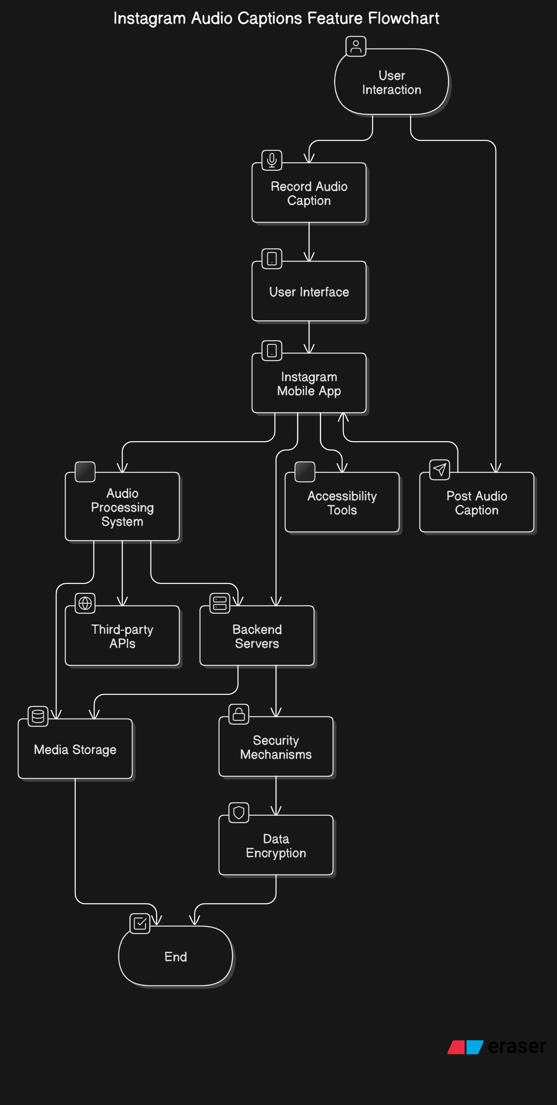

## Entity Relationship Diagram

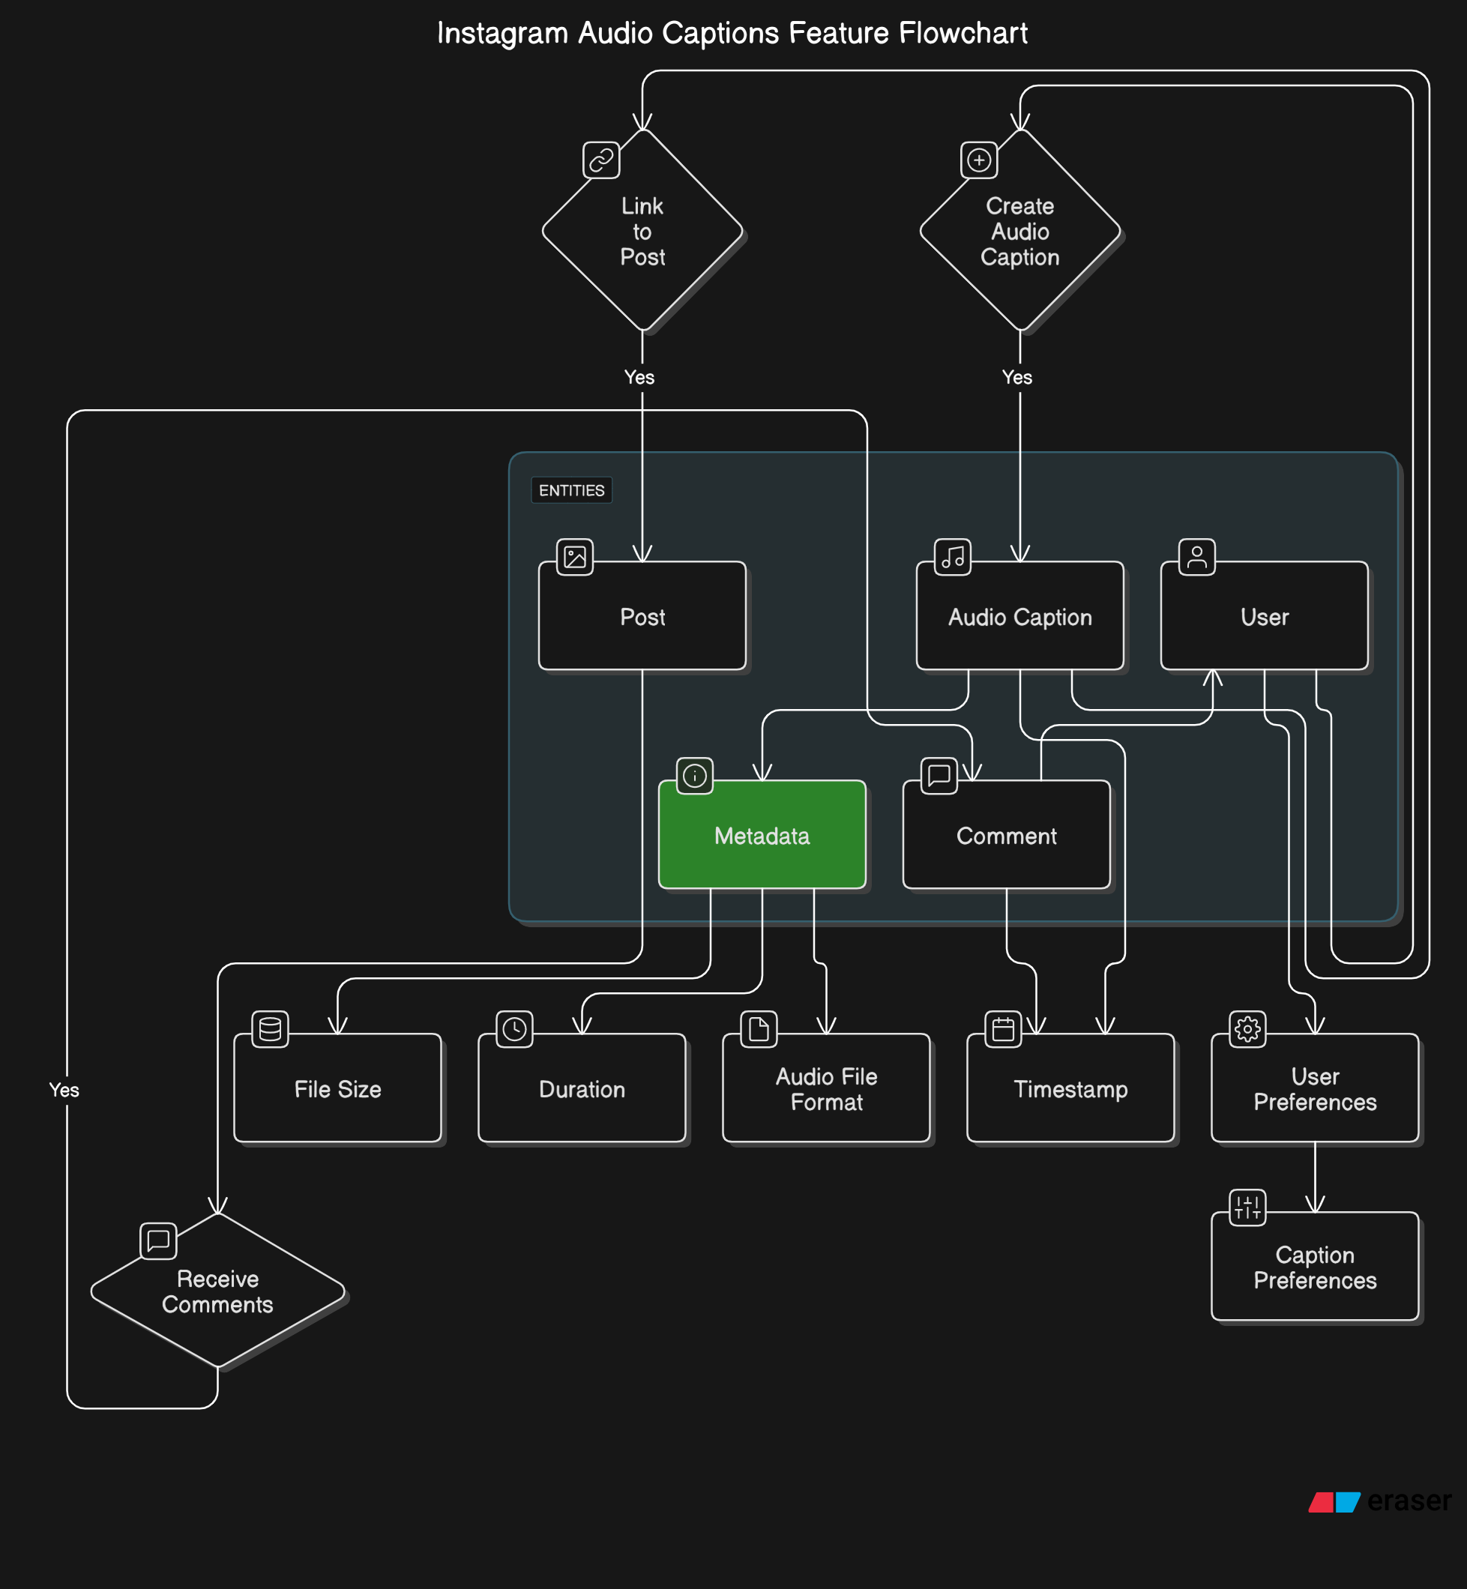

## Process Flow Diagram

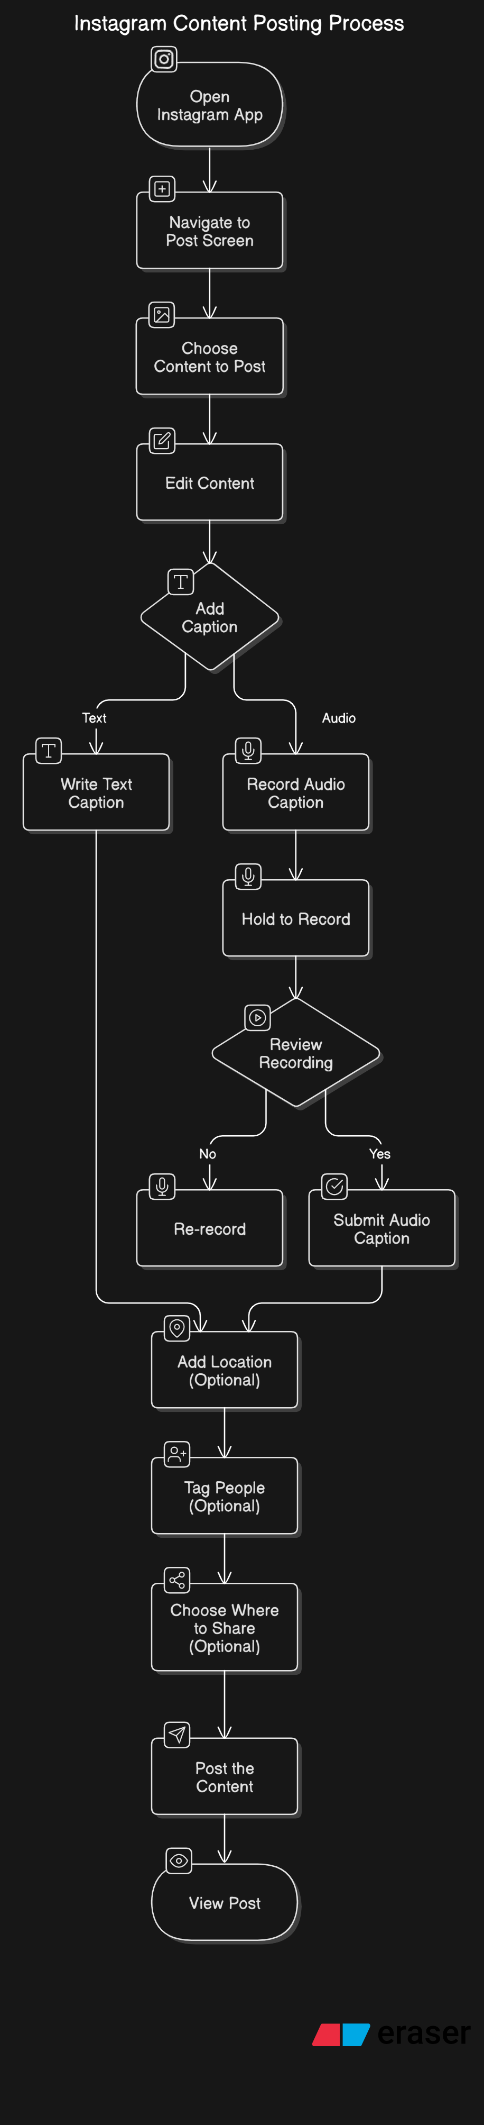

# **Assumptions/Constraints/Risks/Dependencies**

## Assumptions

| **ID** | **Assumption Description** | **Impact** |
| --- | --- | --- |
| A1 | Users will have access to stable internet connections for recording and uploading audio captions. | This will impact performance expectations, as slower internet connections could lead to poor user experience. |
| A2 | Instagram will maintain its current content management system and API structure for the new feature integration. | Assumes no major changes to Instagram's backend systems that would affect how the new feature integrates. |
| A3 | The target audience (Instagram users) will have smartphones capable of recording audio. | The project is assuming that the vast majority of users will have the necessary hardware for this feature. |
| A4 | Instagram’s current accessibility standards will be adequate for integrating audio captions. | Assumes that Instagram’s accessibility infrastructure is sufficient to support additional features for visually impaired users. |
| A5 | No major third-party service disruptions (e.g., cloud storage or audio processing APIs) will occur during the project lifecycle. | Assumes external dependencies like cloud storage or APIs will function as expected without service downtimes or data breaches. |

## **Risks**

| **ID** | **Risk Description** | **Likelihood** | **Impact** | **Mitigation/Workaround** |
| --- | --- | --- | --- | --- |
| R1 | **Low User Adoption**: Users may not engage with the audio caption feature, leading to underutilization. | Medium | High | Implement a strong user onboarding process, including tutorials and in-app prompts. Use marketing campaigns to highlight the feature. |
| R2 | **Performance Issues**: Slow processing times for audio captions or lag in playback could negatively affect the user experience. | High | High | Optimize the backend infrastructure for fast audio processing and playback. Perform extensive load testing before launch. |
| R3 | **Data Security Concerns**: There’s a risk of unauthorized access to users’ audio recordings or personal data. | Low | High | Implement strong encryption for audio files and user data. Adhere to privacy regulations like GDPR and provide clear user consent for data usage. |
| R4 | **Technical Integration Challenges**: Difficulty integrating the audio caption feature with existing Instagram functionalities (e.g., Stories, Reels). | Medium | Medium | Close collaboration with the Instagram development team to ensure compatibility and plan for potential technical hurdles during integration. |
| R5 | **Accessibility Issues**: The feature may not be fully accessible to all users, especially those with hearing or visual impairments. | Low | Medium | Conduct regular accessibility audits and engage with accessibility consultants. Provide alternative text-based options for audio captions. |
| R6 | **External API or Service Failure**: If third-party services like cloud storage or transcription APIs fail, it could impact the feature’s functionality. | Low | High | Establish backup plans, such as using multiple cloud providers. Monitor service performance to detect issues early and switch to alternatives if needed. |

## **Constraints**

| **ID** | **Constraint Description** | **Impact** |
| --- | --- | --- |
| C1 | **Timeframe**: The project must be launched by the end of Q2 to align with Instagram’s planned marketing campaign. | The tight deadline may put pressure on development, testing, and feature refinement. |
| C2 | **Budget**: There is a fixed budget allocated for the feature’s development, which limits the scope of additional features. | Limited resources could result in prioritizing core functionalities over additional “nice-to-have” features. |
| C3 | **Platform Compatibility**: The feature must be compatible with both Android and iOS platforms, which may require additional development time. | Extra effort is required to ensure the feature works seamlessly on different operating systems, potentially extending development time. |
| C4 | **Compliance**: The feature must comply with global data protection and privacy regulations (e.g., GDPR, CCPA). | Legal compliance requirements may introduce additional overhead in terms of data processing, storage, and user consent. |
| C5 | **Data Storage**: Audio files need to be securely stored, requiring Instagram’s infrastructure to handle large amounts of audio data. | The volume of audio files could require scaling Instagram’s data storage solutions, adding complexity to infrastructure planning. |

## **Dependencies**

| **ID** | **Dependency Description** | **Impact** |
| --- | --- | --- |
| D1 | **Instagram Backend Infrastructure**: The feature depends on Instagram’s current infrastructure for media management and storage. | If Instagram’s backend systems are not optimized or ready for integration, delays or additional work may occur. |
| D2 | **Cloud Storage Services**: The audio files will be stored on cloud services (e.g., AWS, Google Cloud). | Delays or issues with cloud services may result in data storage bottlenecks or service outages affecting the feature’s performance. |
| D3 | **Accessibility Guidelines**: The feature depends on existing accessibility guidelines and feedback from accessibility consultants. | If these guidelines are not up to date or not properly followed, the feature could fail to meet accessibility standards. |
| D4 | **Third-party Audio Processing APIs**: The feature relies on external services for audio transcription and processing. | If third-party APIs experience downtime or changes to their offerings, it may impact the feature’s ability to transcribe and process audio captions. |
| D5 | **User Feedback**: Continuous feedback from users, especially those with disabilities, is required to refine the feature. | A delay in receiving feedback or lack of representative user engagement could impact the feature’s quality and inclusivity. |
| D6 | **Marketing and Promotion**: Successful user adoption relies on Instagram’s marketing efforts to promote the new feature. | If marketing efforts are not aligned with the feature release, adoption rates may be lower than expected. |

# **Statement Of Business Requirements**

## Background

Instagram is one of the leading social media platforms, known for its diverse range of content creation features that allow users to share visual experiences. With over 2 billion active monthly users, Instagram is committed to continuously evolving and enhancing the user experience, ensuring accessibility and inclusivity for all users, regardless of their physical abilities.

While Instagram has evolved to include innovative features such as Stories, Reels, and Shopping, one area where the platform can improve is the accessibility and engagement of captions on posts. Currently, users can manually write captions or use third-party services to generate them. However, there is a growing demand for more accessible, inclusive, and engaging ways to present captions, especially for users with visual impairments or those who prefer auditory engagement.

The introduction of **audio captions** will enable users to record and attach an audio caption to their posts, providing an alternative way of expressing themselves beyond traditional text captions. This feature will cater to a broader audience, including visually impaired users, and add a layer of interactivity that encourages more diverse forms of content creation. Additionally, with audio captions, Instagram aims to improve user engagement by offering more personalized, dynamic, and creative content options.

This feature will also align with Instagram's ongoing efforts to integrate accessibility into its design, making the platform more inclusive and improving the experience for people with disabilities. By enabling audio-based captions, Instagram not only aims to enhance accessibility but also increase user retention and engagement across its global community.

I’m glad you liked the background! Let’s now dive into the **Current Environment**, **Challenges in the Current Environment**, and **Opportunities for Improvement** for our **Audio Captions Feature**. These sections will help to explain where Instagram stands today and why this feature is a necessary step forward.

## **Current Environment**

Instagram has been a leader in providing a platform for users to share visual content in the form of photos, videos, and Stories. The platform also supports user-generated captions that accompany these posts, helping to provide context, personality, and additional information.

Currently, captions on Instagram are written manually by users, either through the mobile app or by using third-party transcription tools. While text captions are widely used, there are limitations to their effectiveness, particularly for users with visual impairments who may rely on screen readers to access the content. Additionally, the engagement of posts with captions could be enhanced with more dynamic forms of content, such as audio-based captions that engage users in a new way.

Despite the wide use of captions, Instagram has not yet integrated an audio captioning feature natively within the app. While some users have resorted to using other social media platforms or third-party tools to upload audio files alongside their posts, these solutions are not as seamless or fully integrated into the Instagram experience.

## **Challenges in the Current Environment**

1. **Limited Accessibility for Visually Impaired Users**:
   * Current text-based captions on Instagram may not fully address the needs of visually impaired users. Although Instagram offers features like screen reader support, the lack of audio captions limits the platform’s ability to offer an inclusive experience.
2. **Manual Captioning**:
   * Users must manually write captions, which can be time-consuming and may not always fully capture the tone or intent of the post. This process can also be challenging for those with physical disabilities or those who prefer speaking over typing.
3. **Fragmented User Experience**:
   * Many users resort to third-party tools or external apps to add audio or voice-based captions to their posts. This process is cumbersome and leads to a fragmented experience where the integration of audio with text is not seamless, which can detract from the overall user experience.
4. **Missed Engagement Opportunities**:
   * Audio captions could present a more engaging and personal way for users to communicate their thoughts, emotions, or context behind their posts. However, the absence of this feature limits the potential for increased user interaction and creative expression on the platform.

## **Opportunities for Improvement**

1. **Enhanced Accessibility**:
   * Adding audio captions would improve Instagram’s accessibility for visually impaired users, allowing them to experience content in a more inclusive manner. It would also help Instagram align with accessibility regulations and guidelines, enhancing its reputation as a socially responsible platform.
2. **Increased Engagement and Personalization**:
   * Users could offer more dynamic, personalized captions through voice, adding an extra layer of creativity to their posts. Audio captions would allow users to convey emotions, tone, and intent more effectively, providing a richer experience for both the creator and the audience.
3. **Boosting User Adoption of Captioning Features**:
   * By offering an alternative to manual text-based captions, Instagram could appeal to users who find typing challenging or inconvenient. This would also help increase the use of captions, as more users would feel comfortable using audio-based alternatives.
4. **Supporting a Diverse User Base**:
   * With a growing emphasis on inclusivity, Instagram has an opportunity to serve a more diverse user base. Audio captions would appeal to a wide range of users, including those with physical disabilities, users with different learning preferences, and those who prefer speaking over typing.
5. **Differentiation from Competitors**:
   * By implementing an audio caption feature, Instagram can differentiate itself from competitors like TikTok, Twitter, and Facebook. This unique feature could be marketed as a new and innovative way for users to share their stories, leading to increased user engagement and retention.
6. **Alignment with Instagram’s Accessibility Goals**:
   * Instagram has already made strides to improve accessibility, including introducing features like alternative text for images and closed captions for videos. The introduction of audio captions would further enhance its commitment to making the platform more accessible to everyone.

## Impact On System’s And Processes

| **System/Process** | **Impact** | **Mitigation Strategy** |
| --- | --- | --- |
| **Instagram Mobile App (iOS/Android)** | The addition of an audio recording feature for captions will require updates to the Instagram app, including new UI components (audio button, playback interface, etc.). | Conduct thorough UI/UX testing to ensure a seamless user experience across both iOS and Android platforms. Prioritize backward compatibility. |
| **Backend Infrastructure** | Audio files need to be processed, stored, and served efficiently, requiring additional backend infrastructure and possibly higher data storage capacity. | Scale server capacity, optimize cloud storage solutions, and implement load balancing to accommodate the increased data volume and traffic. |
| **Media Management System** | The current media management system must support storing and serving audio files alongside images and videos. This may involve updates to the content delivery network (CDN). | Update the media management system and integrate it with the audio captioning system. Optimize CDN and storage for audio file delivery. |
| **Audio Processing System** | Audio files need to be processed for clarity, transcription (if applicable), and playback functionality. The system will require optimization to handle large volumes of audio data. | Use audio processing APIs and ensure they are scalable. Implement real-time audio transcription and processing to minimize delays. |
| **Speech-to-Text (Transcription) Services** | If transcription is enabled, third-party services will be required to convert speech to text. This may introduce additional costs and complexity. | Establish service level agreements (SLAs) with third-party vendors. Ensure scalability and redundancy for transcription services to avoid delays. |
| **Accessibility Features** | Integration of audio captions will impact Instagram’s accessibility features (screen reader compatibility, alternative text support, etc.). | Work closely with accessibility experts to test and optimize for inclusivity. Ensure audio captions are compatible with screen readers and other assistive technologies. |
| **User Authentication and Data Privacy** | User data, especially audio files, will need to be handled with increased attention to privacy and security standards (e.g., GDPR, CCPA). | Implement end-to-end encryption for audio files. Update data privacy policies and obtain explicit user consent for audio data processing. |
| **Content Moderation Systems** | The introduction of user-generated audio captions will require the content moderation system to be adapted to detect inappropriate or harmful content in audio. | Update content moderation algorithms to analyze audio content for inappropriate language or harmful speech. Provide users with reporting tools for inappropriate audio captions. |
| **Notifications & Feed Algorithms** | Instagram’s notification system and post feed algorithms may need to adapt to display and notify users of posts with audio captions, which is a new type of content. | Modify notification and feed algorithms to recognize audio caption posts and tailor user notifications accordingly. Test for proper display of audio captions in feeds. |
| **Marketing & Promotion Processes** | The feature will require new promotional campaigns, marketing content, and potentially training for users to understand and adopt the new audio caption functionality. | Develop educational materials, in-app guides, and tutorials. Plan marketing campaigns to raise awareness of the new feature. Ensure smooth onboarding for new users. |

# **Business Process**

## Current

**1. Opening Instagram App**

The user opens the Instagram app on their mobile device (iOS or Android).

**2. Navigating to the Post Screen**

On the home screen, the user taps the **"+"** button located either at the top-right corner of the screen or at the bottom (depending on the version of the app) to start creating a new post.

**3. Choosing the Content to Post**

**Option to Take a New Photo/Video**: The user can either take a new photo or video by selecting the camera option.

**Option to Select from Gallery/Library**: Alternatively, they can select an existing photo or **video from their device’s gallery or photo library.**

**4. Editing the Content**

Once the content is selected, users are taken to the editing screen where they can:

**Apply Filters**: Users can choose from a variety of filters to enhance the image or video.

**Adjust Settings**: Users can adjust brightness, contrast, saturation, etc., using Instagram’s built-in editing tools.

**5. Adding a Caption**

Users are prompted to enter a **caption** for the post. This is typically where they can add text-based content, hashtags, mentions, emojis, etc. This is a key step as it helps users convey the context or message of their post.

**6. Adding Location (Optional)**

Users can add a **location tag** to their post, associating it with a specific place. This is optional but commonly used for posts related to travel or events.

**7. Tagging People (Optional)**

The user has the option to **tag people** in the post by entering their Instagram handles. This can be done by tapping the “Tag People” option.

**8. Choosing Where to Share (Optional)**

Users can choose to share the post to other social media platforms like **Facebook** or **Twitter** directly from Instagram, or share it to **Instagram Stories**.

**9. Posting the Content**

Once the user is satisfied with the image/video and the associated caption, they tap the **“Share”** button at the top-right corner to post the content to their Instagram profile.

**10. Viewing Post**

After posting, the content appears in the user’s Instagram feed, and their followers can see it. Users can edit the post or delete it after sharing if needed.

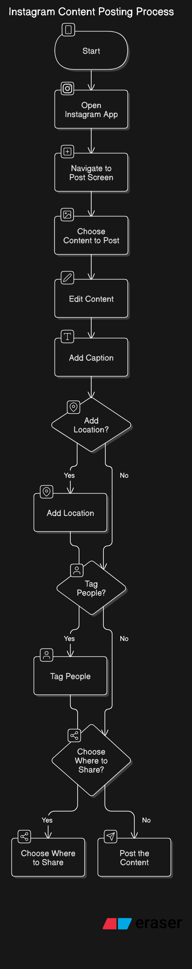

## New Process

1. **Open Instagram app**
   * User opens Instagram on their mobile device (iOS/Android).
2. **Navigate to the post screen**
   * User taps the **"+"** button to create a new post.
3. **Choose content to post**
   * User selects an existing photo/video from their gallery or takes a new photo/video.
4. **Edit content**
   * User applies filters or adjusts settings like brightness, contrast, and saturation.
5. **Add caption**
   * User now has two options:
     + **Option 1: Write a text caption** – The user can proceed as they normally would by typing a caption.
     + **Option 2: Record an audio caption** – The user taps a microphone icon to start recording a spoken caption for the post.
6. **Record Audio Caption (if chosen)**
   * User holds down the microphone icon to record their voice.
   * User can review the recording and re-record if necessary.
   * User can adjust audio settings (e.g., volume, tone) before submitting.
7. **Add location (optional)**
   * User can choose to add a location to the post.
8. **Tag people (optional)**
   * User can tag people in the post.
9. **Choose where to share (optional)**
   * User can share the post on other platforms or to Instagram Stories.
10. **Post the content**

* User taps the **"Share"** button to publish the post with either a text caption or audio caption.

1. **View post**

* The content (photo/video) is posted to the user’s Instagram profile with either a text caption or an audio caption.
* Followers can see and listen to the audio caption (if provided).



# **Systems Requirements**

## Functional Requirements

Functional requirements describe the specific functionalities or capabilities that the system should provide to meet user needs. Here’s a breakdown for our **Audio Captions Feature**:

| **ID** | **Requirement Description** | **Priority** |
| --- | --- | --- |
| FR1 | **Audio Caption Recording**: Users should be able to record an audio caption for their posts using the Instagram mobile app. | Mandatory |
| FR2 | **Audio Caption Playback**: Users should be able to play the recorded audio caption by tapping an audio icon embedded within the post. | Mandatory |
| FR3 | **Audio Caption Editing**: Users should have the ability to re-record or edit their audio caption before posting. | Mandatory |
| FR4 | **Audio Caption Length**: The audio caption should have a maximum length (e.g., 60 seconds) to ensure that it fits within the typical Instagram post format. | Mandatory |
| FR5 | **Audio Caption Transcription (Optional)**: The system should offer an optional feature to transcribe the audio caption into text (for accessibility and searchability). | Desirable |
| FR6 | **Audio File Storage**: The audio caption must be stored securely on Instagram’s cloud infrastructure and be retrievable when a user views the post. | Mandatory |
| FR7 | **Multi-Language Support**: The feature should support audio captions in multiple languages based on the user’s language preferences. | Desirable |
| FR8 | **Accessibility**: The audio caption feature must be compatible with screen readers, providing an alternative text description of the audio for visually impaired users. | Mandatory |
| FR9 | **Notification System**: Users should be notified when a post with an audio caption is created by someone they follow, especially if they have enabled notifications for new posts. | Desirable |
| FR10 | **Privacy and Security**: Audio captions should be treated as sensitive user-generated content, ensuring proper privacy controls and data protection measures are in place. | Mandatory |

## Non-Functional Requirements

Non-functional requirements define the quality attributes, system performance, and constraints under which the system operates. Here are the key non-functional requirements for the **Audio Captions Feature**:

| **ID** | **Requirement Description** | **Priority** |
| --- | --- | --- |
| NFR1 | **Performance**: The system should allow users to record, upload, and playback audio captions with minimal delay (ideally under 5 seconds for recording and playback). | High |
| NFR2 | **Scalability**: The platform should be able to handle millions of users simultaneously recording, uploading, and playing back audio captions without significant performance degradation. | High |
| NFR3 | **Availability**: The audio caption feature should be available 99.9% of the time, ensuring minimal downtime. | High |
| NFR4 | **Security**: All audio files and associated metadata must be encrypted both during storage and while being transmitted over the network to ensure user privacy and data protection. | High |
| NFR5 | **Usability**: The feature should be intuitive and easy to use for all Instagram users, including those with limited technical knowledge. The UI should not be cluttered, and instructions should be clear. | High |
| NFR6 | **Accessibility**: The feature must be fully accessible to users with disabilities, meeting WCAG (Web Content Accessibility Guidelines) standards, including compatibility with screen readers. | High |
| NFR7 | **Compatibility**: The feature must work seamlessly across multiple devices (iOS and Android smartphones) and operating system versions, ensuring consistent functionality. | High |
| NFR8 | **Compliance**: The feature must comply with relevant privacy laws (e.g., GDPR, CCPA) and Instagram’s terms of service regarding user-generated content and data privacy. | High |
| NFR9 | **Data Integrity**: Audio captions must be processed and stored accurately, ensuring no loss or corruption of data during transmission or storage. | Medium |
| NFR10 | **Localization**: The feature should be available in all languages supported by Instagram, with proper localization of the audio captioning feature interface. | Medium |

# Definition Of Completion

Will be determined in future Requirements Document and / or future Technical Specification Document.

# **User Stories Summary**

***User Story 1: As a Regular Instagram User***

* **Goal**: I want to record an audio caption for my post so I can express myself more naturally, without the need to type out a long text caption.
* **Acceptance Criteria**:
  + I can record an audio caption easily by tapping on an audio recording button.
  + The audio recording should be seamless and work without delays.
  + I can listen to my audio caption before posting it.

***User Story 2: As an Instagram User with Accessibility Needs***

* **Goal**: I want to ensure my posts are accessible to everyone, including visually impaired users, by providing an alternative to text captions.
* **Acceptance Criteria**:
  + The audio caption should be compatible with screen readers.
  + I should have an option to add a text description or transcription of the audio caption for users with hearing impairments.
  + I can easily toggle the audio caption feature on or off based on my accessibility preferences.

***User Story 3: As a Content Creator/Influencer***

* **Goal**: I want to offer my followers a richer, more engaging way of interacting with my posts, using audio instead of just visual content.
* **Acceptance Criteria**:
  + I can easily add an audio caption to my post alongside my image/video.
  + I can re-record or edit the audio caption before posting to ensure it matches the tone and message I want to convey.
  + I receive analytics on how well my posts with audio captions perform compared to regular posts.

***User Story 4: As a User Concerned with Privacy***

* **Goal**: I want to ensure that my audio captions are stored securely and that I have full control over my content.
* **Acceptance Criteria**:
  + My audio caption should be encrypted during storage and transmission.
  + I should have the option to delete my audio caption at any time, including after it has been posted.
  + The audio caption feature should comply with privacy laws, ensuring my data is handled appropriately.

***User Story 5: As a User Interested in Transcription***

* **Goal**: I want my audio captions to be transcribed into text so that my followers can read the captions if they prefer not to listen to audio.
* **Acceptance Criteria**:
  + I should be able to enable or disable transcription for my audio captions.
  + The transcription should be accurate and easy to read.
  + The transcribed text should be visible alongside or below the audio caption in the post.

***User Story 6: As a User Who Wants to Engage With Audio Content***

* **Goal**: I want to engage with posts that have audio captions by listening to the content directly within the app, without needing to switch to another app.
* **Acceptance Criteria**:
  + I should be able to play the audio caption with a single tap on the post.
  + The audio caption should play smoothly and without any interruptions.
  + I can adjust the audio volume within the app if needed.

# **Impact Urgency**

**1. Audio Caption Recording Functionality**

* **Impact**: High
  + Essential for the feature's core functionality. Without the ability to record an audio caption, users would be unable to utilize the feature as intended, thus diminishing its value. This is key to driving engagement, especially for those who prefer voice-based communication.
* **Urgency**: High
  + This must be one of the first functionalities developed. Without a working recording feature, the feature won't be able to offer any value to users, and the project could be delayed. Timely implementation is crucial to delivering a working product.

**2. Audio Caption Playback**

* **Impact**: High
  + The ability to play the audio caption is central to the feature. Users need to be able to hear their audio message and engage with posts in a more dynamic way. This plays a significant role in user satisfaction and engagement.
* **Urgency**: Medium
  + While important, this feature can follow the development of the recording feature, but should be prioritized after ensuring that the audio recording process works seamlessly. Delays in playback will hinder user interaction.

**3. Audio Caption Editing**

* **Impact**: Medium
  + Users expect the ability to refine their audio captions before posting. This feature will allow for better user experience and control over the content being shared, enhancing the quality of posts. However, it's not as critical as the basic recording and playback functionalities.
* **Urgency**: Medium
  + While important, it’s not essential for the initial launch. The feature can be developed and rolled out after the basic functionality is in place, with a priority on smooth recording and playback.

**4. Audio Caption Transcription**

* **Impact**: Medium
  + Providing a transcription of the audio caption increases accessibility, allowing hearing-impaired users to engage with content. This also boosts the feature’s overall usefulness by allowing users to provide an alternative to audio for their followers.
* **Urgency**: Low
  + While beneficial, transcription is a nice-to-have feature that can be rolled out after the core audio caption functionality is available. Its development can be scheduled later, once the basic features are stable.

**5. Storage of Audio Captions**

* **Impact**: High
  + Secure and efficient storage is critical for the long-term success of this feature. Users' audio captions need to be stored reliably to ensure they are accessible across devices and accounts.
* **Urgency**: High
  + The audio must be stored securely from the outset, ensuring data is protected. Delays in storage setup could lead to data loss or user trust issues, which would hinder adoption of the feature.

**6. Integration with Accessibility Features**

* **Impact**: High
  + Accessibility is a critical element, ensuring that the feature caters to all users, including those with visual or hearing impairments. By ensuring compatibility with screen readers and providing audio caption alternatives, Instagram can enhance its inclusivity and user experience.
* **Urgency**: High
  + Accessibility features must be integrated early in development to avoid delays in launch. Failing to include accessibility will alienate a segment of users, which is unacceptable for a globally used platform like Instagram.

**7. User Privacy and Security**

* **Impact**: High
  + Given the sensitivity of personal audio content, robust security measures must be implemented to protect user data. Without appropriate safeguards, Instagram could face privacy concerns, legal issues, and user trust issues.
* **Urgency**: High
  + Security and privacy must be prioritized from the start to prevent data breaches and ensure compliance with regulations like GDPR. This is non-negotiable for maintaining user trust.

**8. Cross-Platform Compatibility (iOS and Android)**

* **Impact**: High
  + Ensuring that the audio captions feature works smoothly on both Android and iOS platforms is crucial for broad adoption and user satisfaction. Inconsistent experiences across platforms will limit the feature’s effectiveness.
* **Urgency**: High
  + Cross-platform compatibility should be built into the development from the beginning. Delays here could result in fragmented user experiences, leading to dissatisfaction.

**9. User Analytics for Audio Captions**

* **Impact**: Medium
  + Analytics will help measure the effectiveness of audio captions, guiding future updates and improvements. It will also offer insights into user behavior, which can help with marketing and user engagement strategies.
* **Urgency**: Medium
  + While valuable for optimization, this feature can be rolled out after the basic feature is functional. However, it should be planned early to ensure data collection is set up from the start.

# **Approvals**

| **Approver Name** | **Department** | **Role** | **Approval Date** | **Comments/Notes** |
| --- | --- | --- | --- | --- |
| **John Smith** | Product Management | Product Manager | TBD | Approval of overall feature scope and priority. |
| **Sarah Johnson** | Marketing | Marketing Lead | TBD | Approval of business impact and user engagement goals. |
| **Mike Brown** | Development | Lead Developer | TBD | Approval of technical feasibility and resource allocation. |
| **Emily White** | UX/UI Design | Lead Designer | TBD | Approval of user experience and design elements. |
| **Raj Patel** | Legal and Compliance | Legal Counsel | TBD | Approval of privacy, security, and compliance-related aspects. |
| **Laura Green** | Accessibility | Accessibility Specialist | TBD | Approval of accessibility features and inclusivity compliance. |
| **David Clark** | IT Infrastructure | IT Director | TBD | Approval of infrastructure and system requirements. |
| **Daniel Turner** | Operations | Operations Manager | TBD | Approval of operational impact and timeline feasibility. |
| **Adam Mosseri** | Executive Leadership | CEO/Product Lead | TBD | Final approval of the feature, ensuring it aligns with business goals and strategic priorities. |